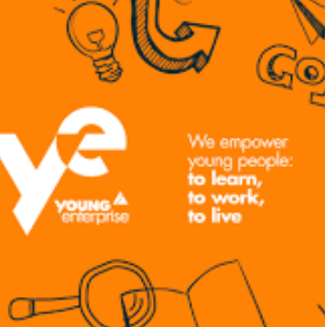

**Young Enterprise (S6)**

**Young Enterprise 2020 at Perth Academy**

The New Company Programme gives all enrolled students the potential to earn 26 SCQF credits which equates to a Higher that Universities and Colleges will recognise.

 The students will complete 3 Units:

·       Unit 1 and 2 offer the 26 SQA accredited points which is a Higher equivalent.

·       Unit 3 offers a further 4 points equivalent to an Advanced Higher.

This course is widely recognised by employers as well as with Universities and Colleges. It can really make the difference on any application to have participated in this programme.

Due to our lockdown situation the plan would be (where feasibly possible) to begin with offering a possible NPA in Business and Admin as well as incorporating Employability units where possible as well.

This is a great opportunity to give students the opportunities to gain as many additional qualifications/experiences and certificates as possible.

Not to mention they will be assigned mentors from industry to assist them on their journey. This includes interview skills and techniques as an example.

As part of the process they will also get the opportunities to sell their products/services and compete in the Regional Final where the winners progress to the National Final.

All round an excellent way to promote and develop DYW in a realistic platform.