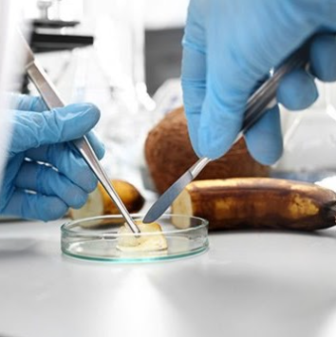

S5/6 National 5 and Higher Health and Food Technology

What are the aims of this course?

The purpose of this course is to allow candidates to develop and apply practical and technological skills, knowledge and understanding to make informed food and consumer choices.

The course has six broad and inter-related aims which allow candidates to:
• develop knowledge and understanding of the relationships between health, food and nutrition
• develop knowledge and understanding of the functional properties of food
• make informed food and consumer choices
• develop the skills to apply their knowledge in practical contexts
• develop organisational and technological skills to make food products
• develop and apply safe and hygienic practices in practical food preparation

What will I be learning about in this course?

Candidates will develop knowledge and understanding of the relationship between food, health and nutrition, dietary needs for individuals and groups at various stages of life, explain current dietary advice and through practical activities will produce and reflect on food products which meet individual needs.
They will develop knowledge and understanding of the functional properties of ingredients in food and their use in developing new food products, develop an understanding of the stages involved in developing food products and, through a problem-solving approach, produce a food product to meet specified needs and will apply knowledge and understanding of safe and hygienic food practices.
They will develop knowledge and understanding of consumer food choices, explore factors which may affect food choices and develop knowledge and understanding of contemporary food issues. They will consider technological developments in food and organisations which protect consumer interests and will develop knowledge and understanding of food labelling and how it helps consumers make informed food choices.

What skills will I develop?

The course uses an experiential, practical and problem-solving approach to learning, which develops knowledge and understanding, and practical skills. The course uses real-life situations taking account of local, cultural and media influences and technological innovations.

What learning and teaching approaches will I experience?

Direct teaching, self study, analysis, planning & evaluating techniques, answering handling information questions, group and paired work, visits/talks from outside agencies.

How will I be assessed?
Contains 3 Units of work which will be assessed internally at end of each unit :

>Food for Health
>Food Product Development
>Contemporary Food Issues
There is a practical assignment & question paper which will draw on, extend & apply the skills they have learned during the course to determine the overall grade for the course.

What are the homework requirements?

Each unit of work has a homework booklet related to learning in the classroom.

What might this course lead to in the future?

Can lead to Higher/Advanced Higher Health & Food Technology, Hospitality National 5 or Practical Cake Craft National 5.
Further education & employment in food, care & welfare

This course requires £10 for the year to cover practical lessons

