Introduction to Hospitality – Practical Cookery
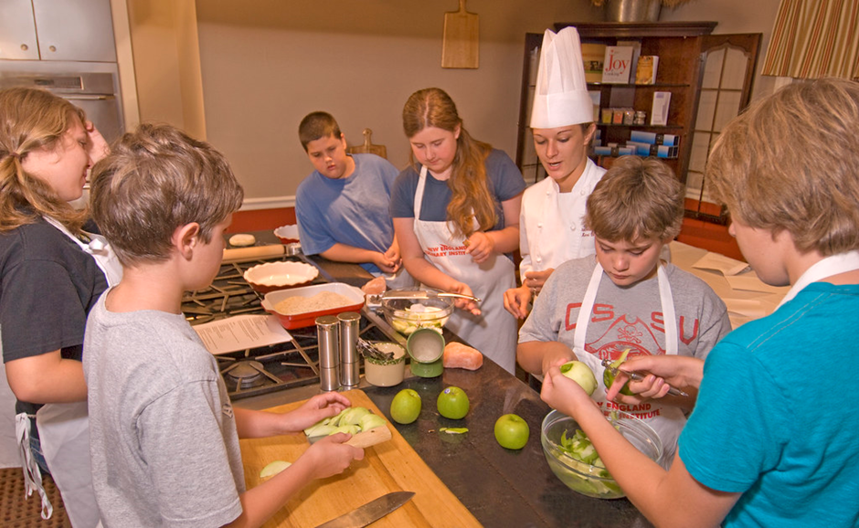
What are the aims of this course?
The course, which is practical & experimental in nature aims to develop a range of basic cookery skills and food preparation techniques as well as basic planning, organisational & time management skills, in hospitality-related contexts.
What will I be learning about in this course?
Students will learn new cookery skills, processes & techniques.
They will understand different ingredients & how to use them safely & hygienically.
They will also learn organisational skills for practical cooking.
What skills will I develop?
Develop an understanding of hygienic food handling, planning work to integrate practical skills, developing skills in food preparation techniques and cookery processes, identifying equipment used in food preparation and cooking and gaining knowledge of the terms used in food preparation techniques and cookery processes.
What learning and teaching approaches will I experience?
Practical cookery demonstrations, group & paired work, visits from colleges and food outlets, visits from outside agencies.
How will I be assessed?
Other assessments will require students to carry out practical tasks and will be assessed on skills, techniques and processes. An end of unit written assessment.
Students will also be assessed practically for safety and hygiene.
What are the homework requirements?
Homework will be issued in Teams and will be related to learning in the classroom.
What might this course lead to in the future?
Can lead to Hospitality Practical Cookery National 4/5, Creative Cake Production National 5 or other college related courses.
Employment in the Hospitality, catering and tourism industries.

