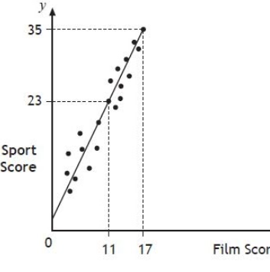

National 5 Maths

What are the aims of this course?
The aim of the course is to enable you to build on your previous mathematical experience. Abstract mathematical concepts are included as well as many mathematical techniques that you will find useful in everyday life. The study of Mathematics provides you with many valuable skills and is often very helpful when you are seeking employment.
What are the recommended entry levels for this course?
A pass at National 4 or equivalent. However, entry onto the National 5 course will be at the discretion of the department and will be based on the student’s final grade at National 4, ability and behaviour.

What content is included in this course?
The course is made up of three units:-
Expressions & Formula | Relationships | Applications
Applying numerical skills to simplify surds/expressions using the laws of indices.  Applying algebraic skills to manipulate expressions.  Applying algebraic skills to algebraic fractions.  Applying geometric skills linked to the use of formulae. | Applying algebraic skills to linear equations.  Applying algebraic skills to graphs of quadratic relationships.  Applying algebraic skills to quadratic equations.  Applying geometric skills to lengths, angles and similarity.  Applying trigonometric skills to graphs and identities | Applying trigonometric skills to triangles which do not have a right angle.  Applying geometric skills to vectors.  Applying numerical skills to fractions and percentages.  Applying statistical skills to analysing data.

What skills will I develop?
The National 5 Mathematics course provides essential skills for taking Mathematics further in the world of work or future study. National 5 Mathematics will give the learner confidence when dealing with number work in real life. It will encourage abstract thinking, model real-life situations, make generalisations and helps provide skills needed to interpret and analyse information, assess risk and make informed decisions.
What learning and teaching approaches will I experience?
The course will be teacher led, with students being actively involved in learning through practical work. Emphasis is placed on problem solving, as it is essential that students develop a systematic approach to the solution of problems and learn to communicate their results in a meaningful way.
To meet the needs of our students, a variety of resources will be used, including textbooks, audio-visual materials and computers.
How will I be assessed?
The SQA external assessment consists of 2 papers – one non-calculator, one calculator. A prelim, which is of the same form as the SQA external exam, takes place in January under exam conditions.
What are the homework requirements?
Homework will be set to practise the skills that have been learnt during lessons, and to assess the students understanding of a particular topic, so that additional time may be spent revising a topic if needed.

