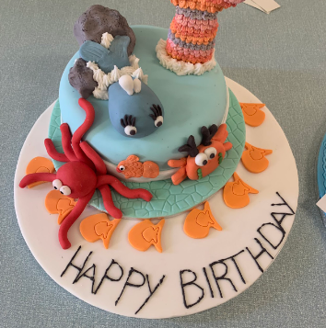

National 5 Creative Cake Craft

S5 and S6 Only
What are the aims of this course?

This is a cake making related course which aims to develop pupils baking and creative skills. It is designed to enable pupils to develop knowledge of cake making and produce commercial standard cakes for different situations.
What are the recommended entry levels for this course?

Discretion of Home Economics Department but would be an advantage to have achieved Hospitality National 4 or 5 or Health & Food Technology National 4 or above.
What content is included in this course?
The Course aims to enable learners to:
develop technical skills in cake baking
develop technical and creative skills in cake finishing
follow safe and hygienic working practices
develop their knowledge and understanding of cake design and follow trends in cake production
acquire and use organisational skills in the context of managing time and
Resources
This course requires £55 to cover practical lessons
What skills will I develop?

In the Baking unit, learners will develop the ability to bake a range of cakes and other items safely and hygienically. In the production of a range of cakes and other baked items, learners will demonstrate specialist skills, techniques and processes. To promote personalisation and choice, this Unit provides opportunities to investigate baking trends and allows learners to apply this knowledge in a range of practical contexts.
In the finishing unit, learners will apply specialised skills and creative techniques. To promote
personalisation and choice, this Unit allows opportunities to investigate trends in cake
finishing and allows learners to apply this knowledge in a range of practical contexts.
What learning and teaching approaches will I experience?

Cake baking and finishing demonstrations, investigation techniques, group & paired work, problem solving, visits to colleges and cake outlets, visits from outside agencies. Preparation and organisation of ingredients and equipment to create a celebration cake.

How will I be assessed?

Ongoing practical observations
Final practical activity (plan, prepare, manufacture & evaluate a cake to a given brief) as well as an externally marked written exam to determine the overall grade for this course.
What are the homework requirements?
Homework will be issued regularly
Investigation work for final assignment.
What are the possible progression routes?

Hospitality National 5 or college related courses.
Employment in catering, hospitality industry and food related employment.

