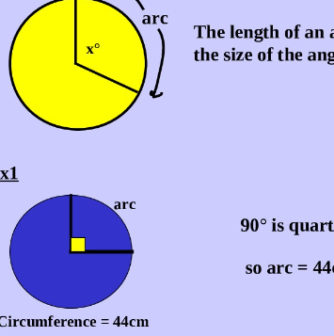

N4/5 Application of Maths

What are the aims of this course?
The purpose of the National 5 Applications Mathematics Course is to motivate and challenge learners by enabling them to think through real-life situations involving mathematics and to form a plan of action based on logic.
The Course develops confidence and independence in being able to handle information and mathematical tasks in both personal life and in the workplace. The Course allows learners to draw conclusions, assess risk and justify decisions based on data presented in a variety of forms.
What are the recommended entry levels for this course?
The entry level is a pass at the level below. However, entry onto the course will be at the discretion of the department.
What skills will I develop?
The mathematical skills within this Course are underpinned by numeracy and designed to develop learners’ mathematical reasoning skills relevant to learning, life and work in an engaging and enjoyable way.
What learning and teaching approaches will I experience?
The course will be teacher led, with students being actively involved in learning through practical work. Emphasis is placed on problem solving, as it is essential that students develop a systematic approach to the solution of problems and learn to communicate their results in a meaningful way.
To meet the needs of our students, a variety of resources will be used, including textbooks, audio-visual materials and computers.
How will I be assessed?
For National 4, 3-unit assessments need to be passed an Added Value Unit Assessment is also required to gain the final award. For National 5 an SQA exam is undertaken, graded A-D.
What are the homework requirements?
Homework will be set to practise the skills that have been learnt during lessons, and to assess the students understanding of a particular topic, so that additional time may be spent revising a topic if needed.
What are the possible progression routes?
A pass at National 4 Applications may lead on to study at National 5 Applications. A grade A at National 5 Applications may lead on to study National 5 Mathematics Entry will be at the discretion of the department, and will be based on the student’s final grade, ability and behaviour. Applications of Mathematics courses will also serve as a useful qualification for further education or employment.

