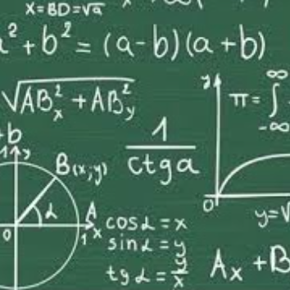

Higher Maths
What are the aims of this course?
The course will extend students mathematical skills, knowledge and understanding in a way that recognises problem solving as an essential skill. You will be encouraged to challenge your thinking and decision making to solve problems and integrate mathematical knowledge.
What are the recommended entry levels for this course?
Entry onto the Higher course will be in discussion with the department and will be based on the student’s final grade being usually an A or B at National 5 Mathematics.
What content is included in this course?
The topics which are covered are:-
1.Mathematics: Expressions and Functions
The general aim of this Unit is to develop knowledge and skills that involve the manipulation of expressions, the use of vectors and the study of mathematical functions. The Outcomes cover aspects of algebra, geometry and trigonometry, and also skills in mathematical reasoning and modelling.
2.Mathematics: Relationships and Calculus
The general aim of this Unit is to develop knowledge and skills that involve solving equations and to introduce both differential calculus and integral calculus. The Outcomes covers aspects of algebra. Trigonometry, calculus and also skills in mathematical reasoning and modelling.
3.Mathematics: Applications
The general aim of this Unit is to develop knowledge and skills that involve geometric applications, applications of sequences and applications of sequences and applications of calculus. The Outcomes cover aspects of algebra, geometry, calculus and also skills in mathematical reasoning and modelling.

What skills will I develop?
The study of Higher Mathematics develops logical reasoning, analysis, problem-solving skills and the ability to think in abstract ways, as well as offering opportunities for creativity. It is a rich and stimulating subject with the capacity to engage and fascinate learners and has a wide applicability to science, engineering, technology, business, industry and not least to everyday life. Mathematics is an ever-expanding body of knowledge, skills, concepts and techniques essential in the efficient handling of information and the solution of problems.
What learning and teaching approaches will I experience?
The course will be teacher led, with students being actively involved in learning through practical work. Emphasis is placed on problem solving, as it is essential that students develop a systematic approach to the solution of problems and learn to communicate their results in a meaningful way.
It must be stressed that students will be required to do work in their own time to reinforce the work done in class, as well as homework tasks.

How will I be assessed?
The SQA external assessment consists of 2 papers – one non-calculator, one calculator. A prelim, which is of the same form as the SQA external exam, takes place in January and April under exam conditions.
What are the homework requirements?
Homework will be set to practise the skills that have been learnt during lessons, and to assess the students understanding of a particular topic, so that additional time may be spent revising a topic if needed.
A student will be expected to do a minimum of 3-4 hours work a week, this will consist of homework and consolidation work.
What are the possible progression routes? Students may progress to the Advanced Higher Mathematics, though entry onto the Advanced Higher course will be at the discretion of the department, and will be based on the student’s final grade, ability and behaviour. The Higher qualification could also be used either as a general requirement or specific entry requirement for mathematics, engineering or science HNC/D or degree course.

