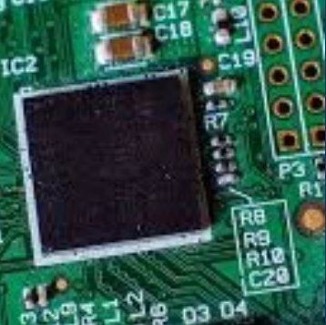

**Higher Computing Science**

|  |
| --- |
|  |
| **What are the aims of this course?**    The aims of this course are to provide:    ·          knowledge and understanding of computer concepts  ·          practical skills in the use of computer hardware and software  ·          ability to solve problems by applying knowledge, understanding and practical skills  ·          awareness of the professional, social, ethical and legal implications of computing  ·          ability to communicate computing concepts clearly and concisely using appropriate terminology |
| **What are the recommended entry levels for this course?**    National 5 computing Science at Grade A/B and/or the informed opinion of the Principal Teacher of Computing. |
| **What content is included in this course?**    Course content is split into two units – **Software Design and Development**  **Information System Design and Development**    It includes the following:    ·           data representation, computer & processor structure, virtual machines, emulators, peripherals, networking issues  ·           the software development cycle, languages and their environments, high-level language programming constructs, standard algorithms, testing and documenting solutions  ·           database structures and links, web based structures and links, media types, Javascript, HTML, web browsers, operating systems, cloud systems, security/legal/environmental implications |

|  |
| --- |
| **What are the homework requirements?**    Homework will be issued on at least a weekly basis and will include the following activities:    ·           answering written questions  ·           learning necessary facts and reading over notes  ·           preparing programs for entry in class  ·           writing programming reports    Pupils will be expected to produce homework of a very high standard and to hand it in punctually. |
| **What are the possible progression routes?**    This course leads on naturally to Advanced Higher Computing and isan excellent grounding for all college and university courses that include a computing element. |
| **What skills will I develop?**    As computing is both a science and a technology you will develop the skills to use the increasingly powerful hardware and software tools that are available to benefit society and the ability to become ICT designers of the future. |
| **What learning and teaching approaches will I experience?**    A wide variety of learning and teaching approaches will be adopted – each suited to the individual part of the course being studied. These approaches will include teacher-led lessons and demonstrations, working in pairs and groups, whole class discussions, making use of the Interactive white board, teaching to your peers and individual research. |
| **How will I be assessed?**    The Course assessment for Computing at Higher level will consist of two components:    ·           Question Paper (70%)  ·           Assignment (30%)    The purpose of the question paper is to assess the candidate’s competence to integrate and retain knowledge and understanding and demonstrate higher order cognitive abilities across the contents of all the Units, and in varied contexts, and to demonstrate the ability to communicate computing concepts clearly.    The assignment task provides candidates with the opportunity to demonstrate and integrate the practical skills, knowledge and understanding from the Units, and apply these in a more complex practical context by developing a digital solution to a computing science problem. |